**Assignment no. 3**

**Name:** Jayesh Patil

**Roll no:** T21287

Implement the C program for CPU Scheduling Algorithms:

1. Shortest Job First (Preemptive) and 2. Round Robin with different arrival time.

Also demonstrate zombie and orphan states.

1. Shortest Job First (Preemptive)

|  |
| --- |
| // rollno T21287//  #include <stdio.h> int main()  {  int arrival_time[10], burst_time[10], temp[10]; int i, smallest, count = 0, time, limit; double wait_time = 0, turnaround_time = 0, end; float average_waiting_time, average_turnaround_time;  printf("\nEnter the Total Number of Processes:\t"); scanf("%d", &limit);  printf("\nEnter Details of %d Processesn", limit);  for(i = 0; i < limit; i++)  { printf("\nEnter Arrival Time:\t"); scanf("%d", &arrival_time[i]); printf("Enter Burst Time:\t"); scanf("%d", &burst_time[i]); temp[i] = burst_time[i];  }  burst_time[9] = 9999;  for(time = 0; count != limit; time++)  { smallest = 9; for(i = 0; i < limit; i++)  { if(arrival_time[i] <= time && burst_time[i] < burs t_time[smallest] && burst_time[i] > 0)  { smallest = i;  } }  burst_time[smallest]--; if(burst_time[smallest] == 0)  { |
| count++; end = time + 1; wait_time = wait_time + end arrival_time[smallest]- temp[smallest]; turnaround_time = turnaround_time + end arrival_time[smallest];  } } average_waiting_time = wait_time / limit; average_turnaround_time = turnaround_time / limit;  printf("\n\nAverage Waiting Time:\t%lf\n", average_waiting_tim e); printf("Average Turnaround Time:\t%lf\n", average_turnaround_t ime);  return 0;  } |

# OUTPUT:-

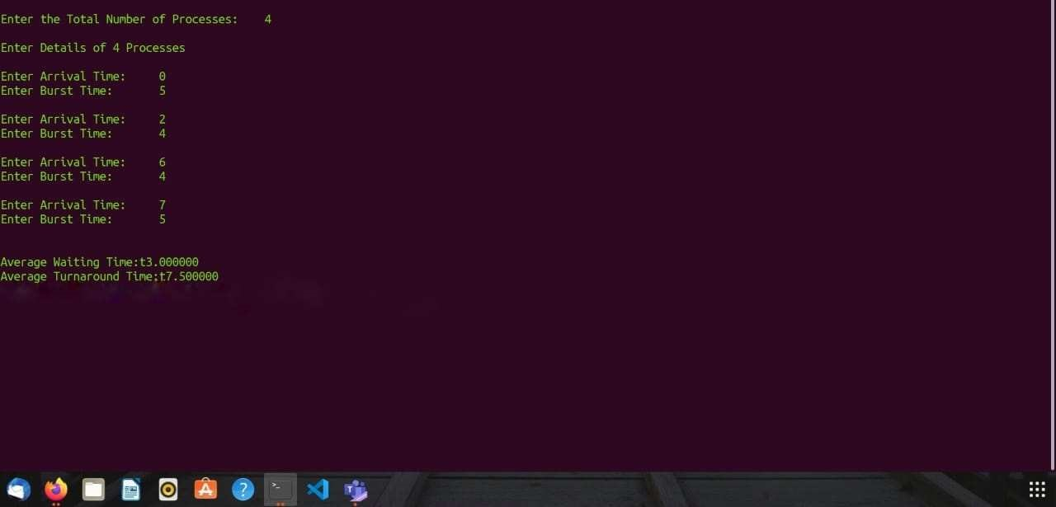

# Round Robin

|  |
| --- |
| #include <stdio.h>    int main()  { int i, total = 0, x, limit, counter = 0, t_quantum; int wait_time = 0, turnaround_time = 0, arrival_time[10], burst_t ime[10], temp[10];  float average_wait_time, average_turnaround_time;  printf("\nEnter Total Number of Processes: "); scanf("%d", &limit); x = limit;  for (i = 0; i < limit; i++)  { printf("\nProvide the details for Process[%d]\n", i + 1);  printf("Arrival Time:\t"); scanf("%d", &arrival_time[i]);    printf("Burst Time:\t"); scanf("%d", &burst_time[i]); temp[i] = burst_time[i];  } printf("\nEnter Time Quantum:\t"); scanf("%d", &t_quantum);    printf("\nProcess ID\t\tBurst Time\t Turnaround Time\t Waiting Ti me\n"); for (total = 0, i = 0; x != 0;)  { if (temp[i] <= t_quantum && temp[i] > 0) |

|  |
| --- |
| { total = total + temp[i]; temp[i] = 0; counter = 1;  }  else if (temp[i] > 0)  { temp[i] = temp[i] - t_quantum; total = total + t_quantum;  } if (temp[i] == 0 && counter == 1)  { x--;  printf("\nProcess[%d]\t\t%d\t\t %d\t\t\t %d", i + 1, burst_ time[i], total - arrival_time[i], total - arrival_time[i] burst_time[i]);  wait_time = wait_time + total - arrival_time[i] burst_time[i];  turnaround_time = turnaround_time + total arrival_time[i]; counter = 0;  } if (i == limit - 1)  {  i = 0;  } else if (arrival_time[i + 1] <= total)  { i++; } else {  i = 0;  }  } average_wait_time = wait_time *1.0 / limit; average_turnaround_time = turnaround_time *1.0 / limit; |
| printf("\n\nAverage Waiting Time:\t%f", average_wait_time); printf("\nAvg Turnaround Time:\t%f\n", average_turnaround_time);  return 0;  } |

**OUTPUT:-**

